Server 2016 (iis 10.0)

Installing IIS 10.0 with the settings required for Sage CRM
To install IIS10.0, use the following steps:
- Open Server Manager.
- Under Manage menu (top right) , select Add Roles and Features:
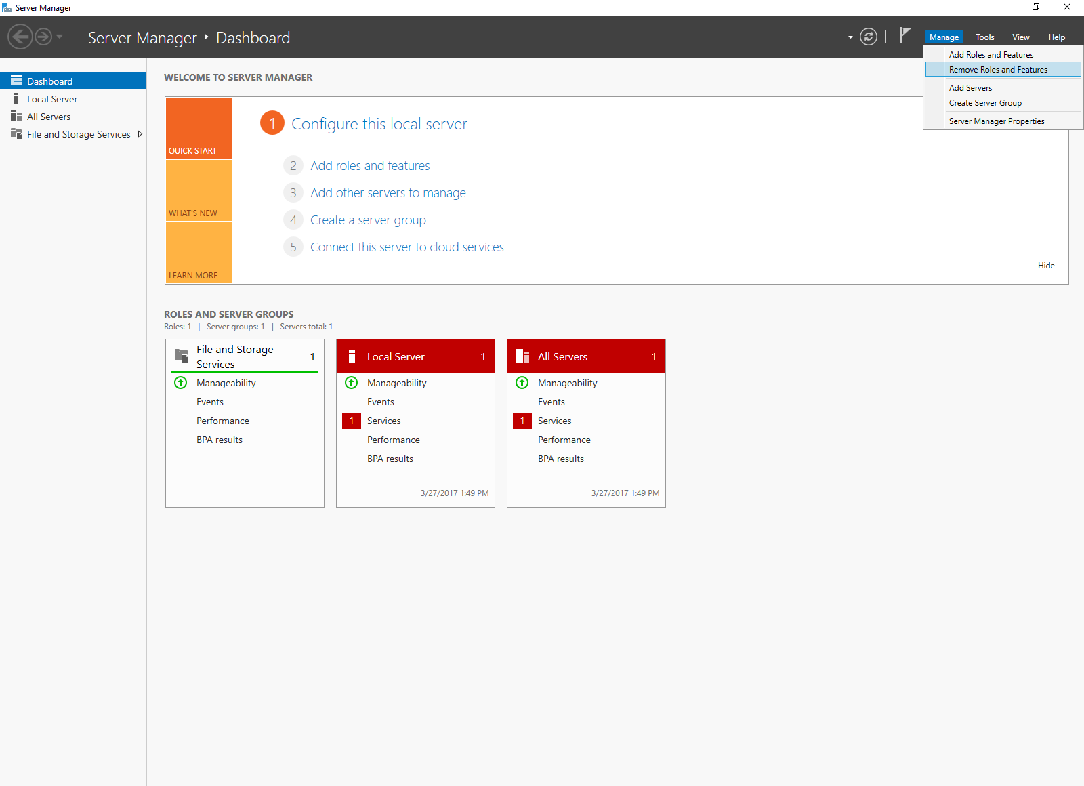

- The Wizard will appear as below, click “Next”
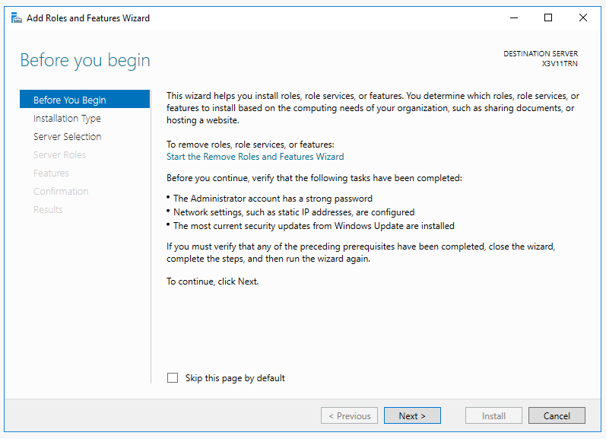
- Select Role-based or Feature-based Installation:
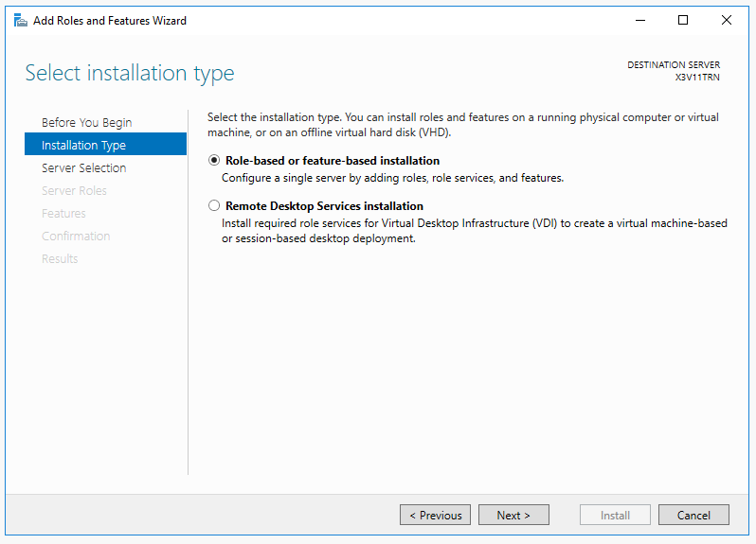

- Select the appropriate server (local is selected by default), as shown below:
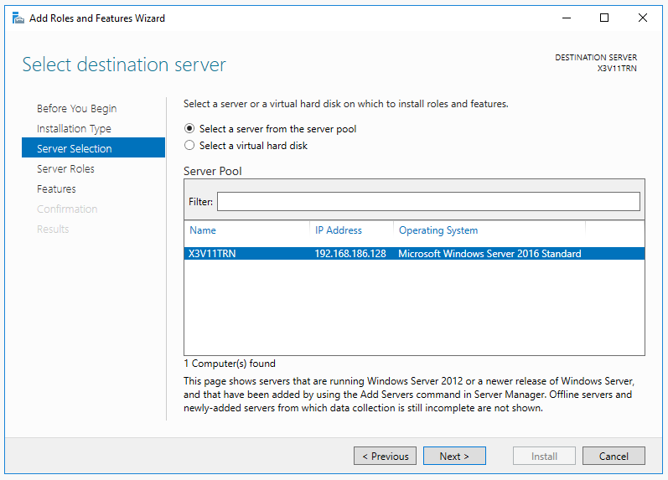
- Select Server Roles screen will appear, Select Web Server (IIS),
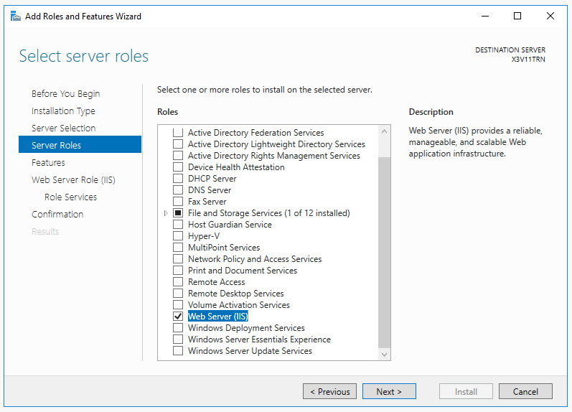

- Add features that are required for Web Server (IIS)? Window will appear, ensure “include management tools” is selected, then click “Add Features”
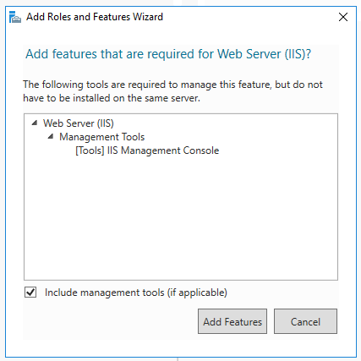
- On the Select features screen, select .NET Framework 3.5 and 4.6 (ensure you select the relevant sub options as per below), then click “Next”
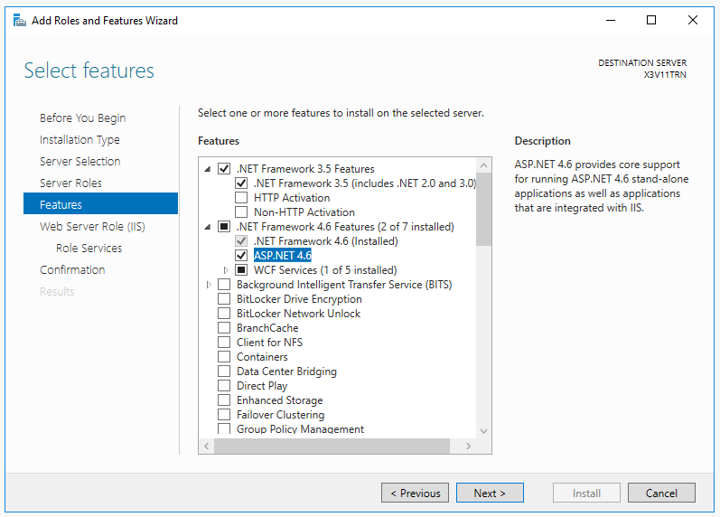

- On the Web Server Role (IIS) screen, click “Next”
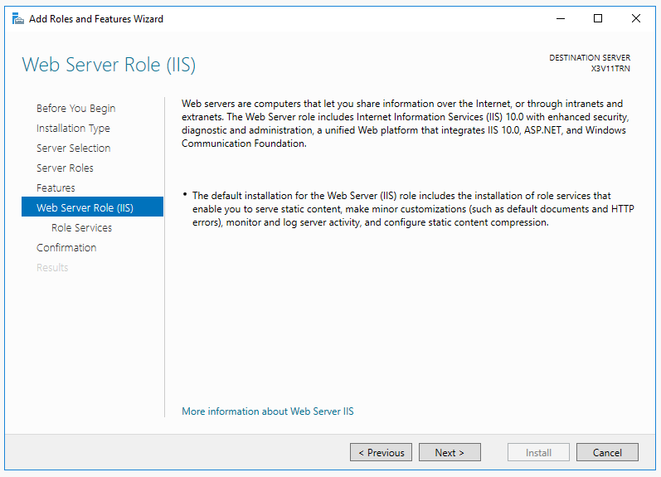

- Customize your installation of IIS, follow the selected options as seen in the below screen shots.
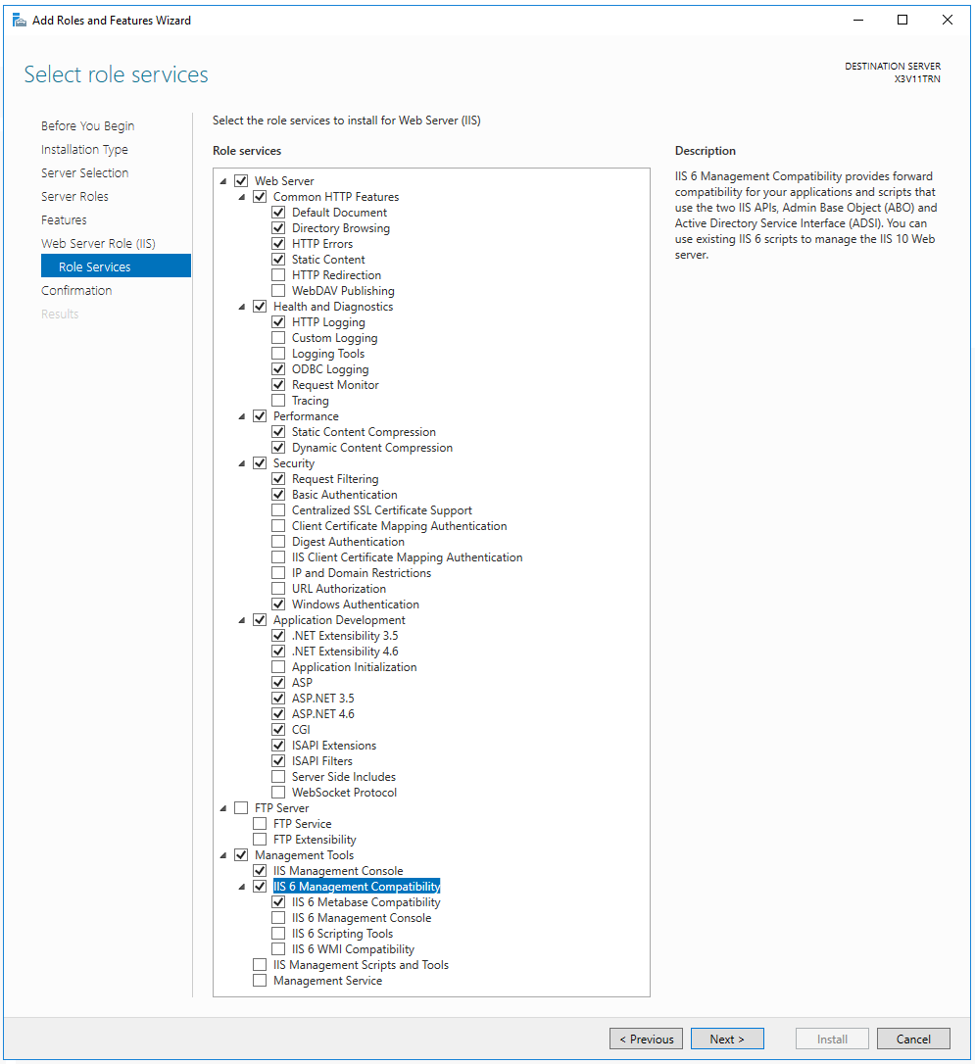
- Click Next
- Confirm your installation selections and Install.

Install Sage CRM > once CRM is installed return to IIS.
On the taskbar, click Server Manager, click Tools, and then click Internet Information Services (IIS) Manager.
On the left hand side, select your server, then “Sites”, then “Default Site”, then your CRM install name ( in my case “CRM”)
Click on the “Authentication” icon.

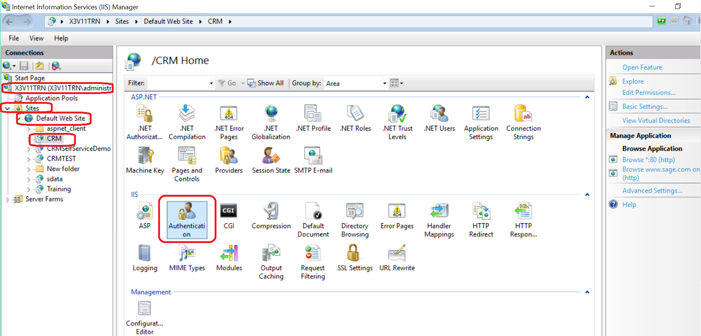

Once “Authentication” is selected select Enable Anonymous Authentication then on the far right side of the screen, select Edit as shown in the following print screen.

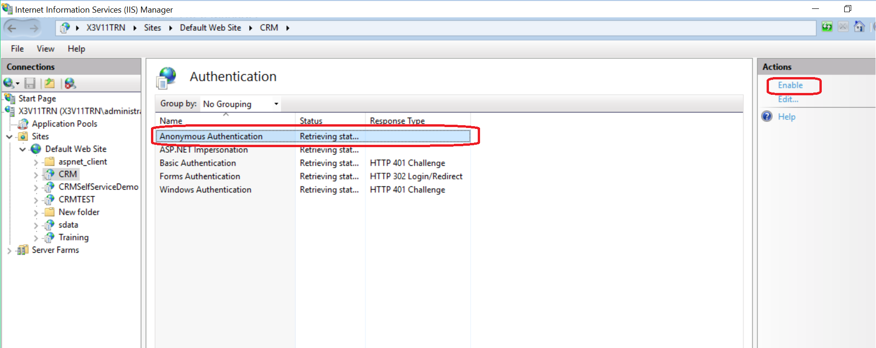

Once the “Edit Anonymous Authentication Credentials” screen is presented,
select IUSR and click OK to close this screen.
As a side note, for security purposes IUSR is not advised, a domain authorized account would preferable
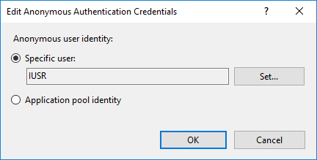

Also Enable “Windows Authentication”
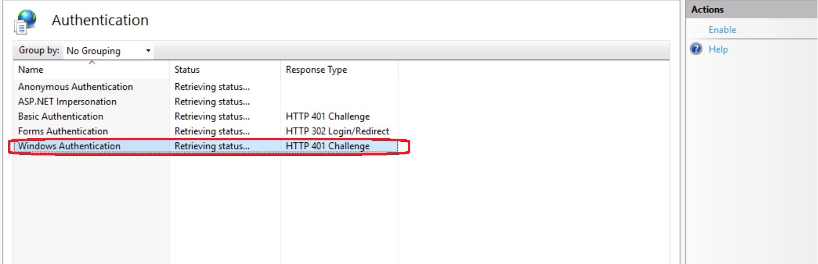

Next select “ASP”, set Enable Parent paths to TRUE. Select “Apply’ on the top right.
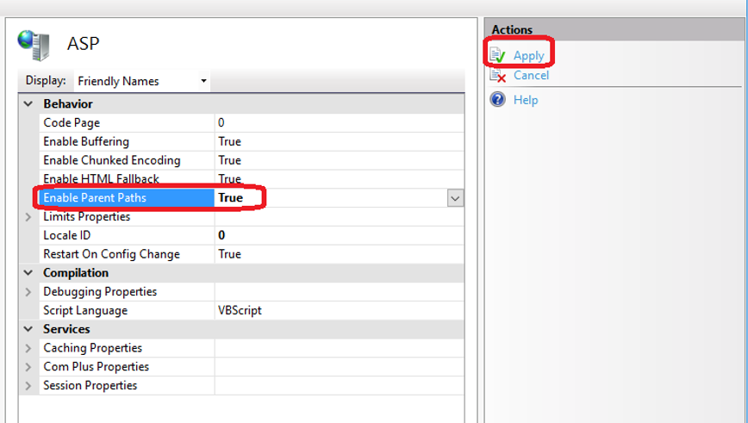

Then click on Application Pools, >> CRM App Pool
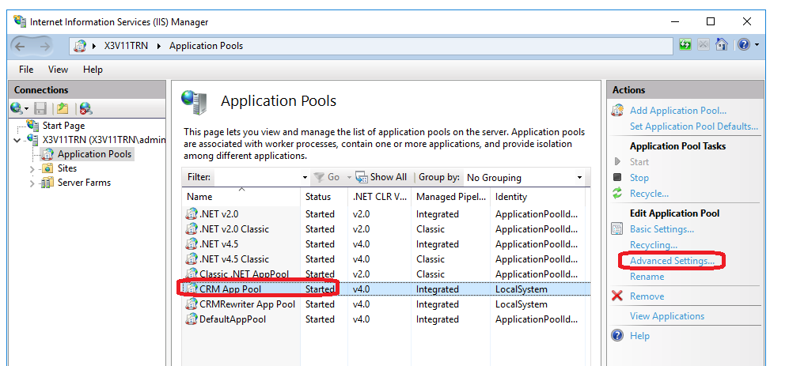

Then “Advanced settings”
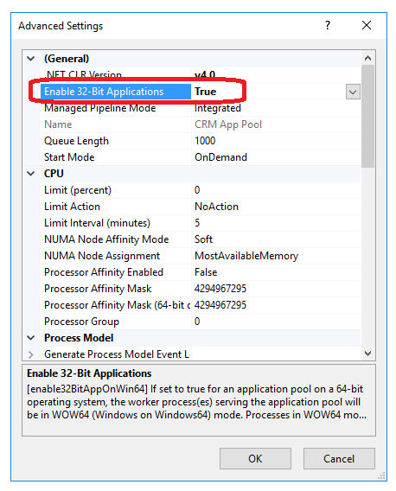

At this point I would recommend that you right click over the server and select STOP.
12. Then right click over the server and select START.
13. With all the changes that have been made a minimum IIS should be reset and at best the server should be rebooted.

