Apply the following steps to perform a Pivot Field Clean-up routine:
- First close all MS Excel files on the local PC
- In Report Manager, right click on the relevant report layout and select Clean Template Pivot Fields
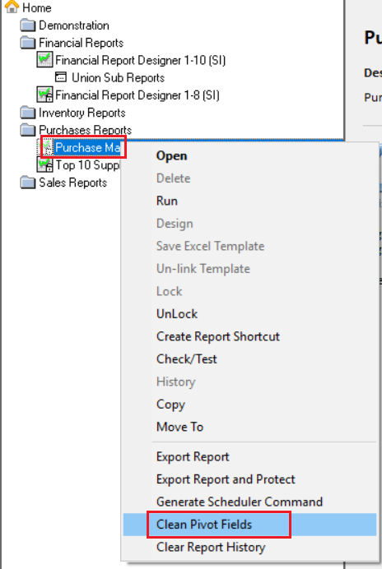

- Select Yes on this message
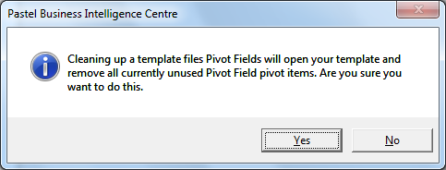

- Click the Select All button below and OK
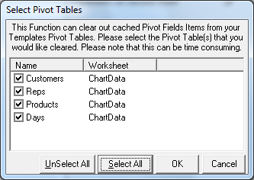
- And again Select All and OK on all the following prompts that may follow until all pivot fields are done
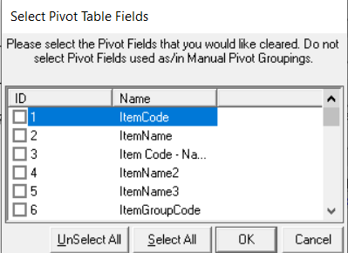
- Notice the clean-up operation being processed at the bottom of the screen
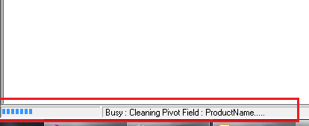

- You might again receive the following type of screens, keep on selecting Select All and Ok until done
- When done, select Yes if you want to save the changes
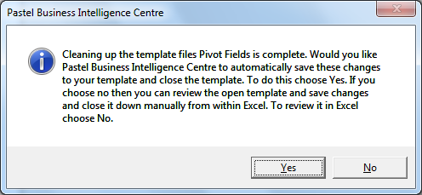
- When done, rerun the report

