ARTICLE

The following critical error message could be displayed when printing or reprinting an invoice (Inventory / Sales Order / Job Costing):

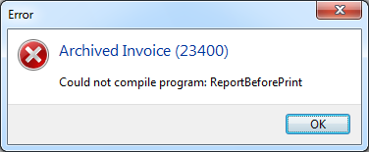

REASON AND SOLUTION:

A possible reason for the above error is the following:

The CopyDescription variable has been deleted on the Invoice design layout screen, as can be seen where it still is supposed to exist when opening a copy of a standard invoice layout:

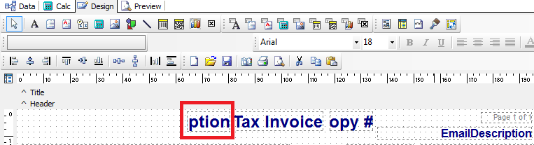

And it will not resolve the problem by only inserting the CopyDescription variable back in its original place, once the original variable has been deleted.

Therefore, do the following:

- Insert the CopyDescription variable to the left of the Tax Invoice (insert the new DBText field in the correct position and define it with data pipeline: plInvNum and field: CopyDescription)

- Keep your focus on the new variable and notice the actual variable name for this new field at the bottom left of the screen: DBtext39 in this case

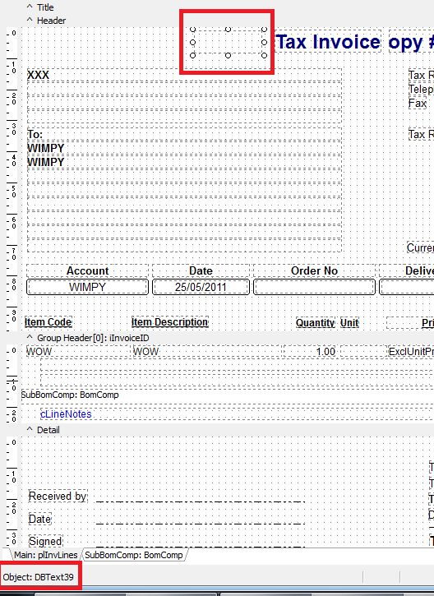

- Select the Calc tab on the top of the screen and find the new variable called DBtext39 under the Groups / Header section of report fields

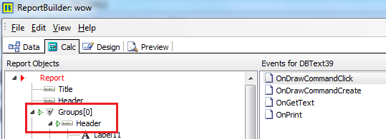

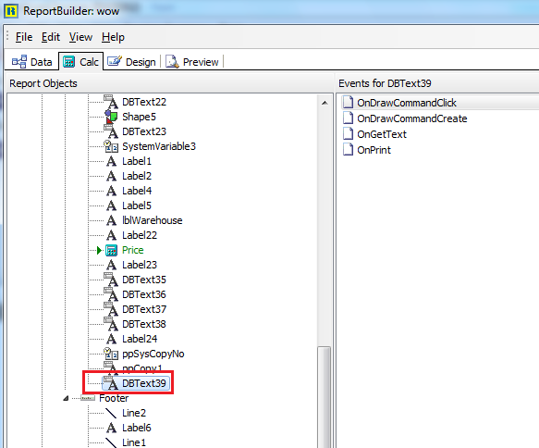

- Rename the variable by selecting it once to focus on it, then selecting it again (not double clicking on it) to ppCopy

- Back on the Design screen, at the bottom, you should now see the correct variable name:

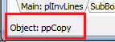

- Save the changed layout and all should be fine now

